**To add data in your table you need “INSERT” statement.**

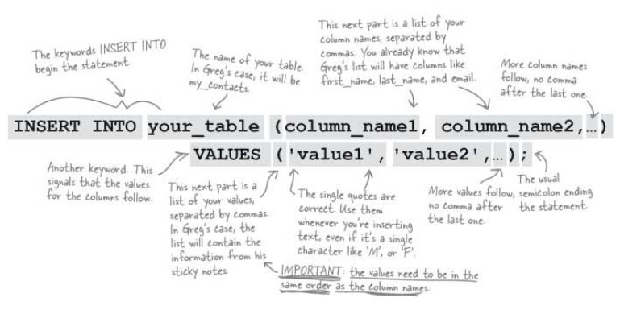

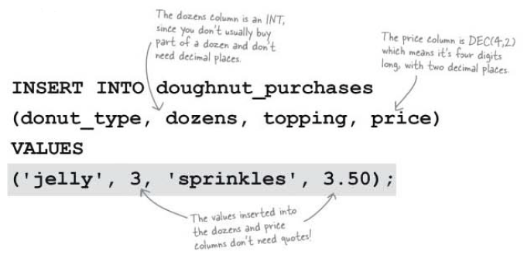

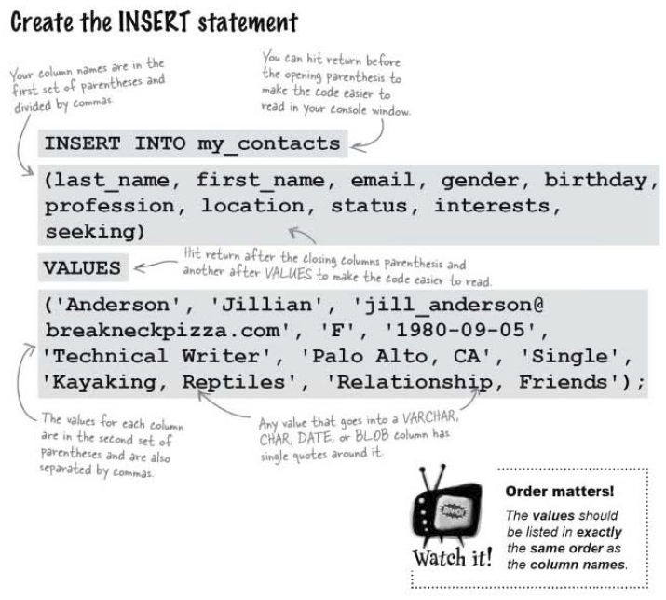

**Variations on an INSERT statement**

There are three variation of **INSERT** statement you should know about.

1. **Changing the order of columns**

You can change the order of your column names as long as the matching values for each column come in that same order!

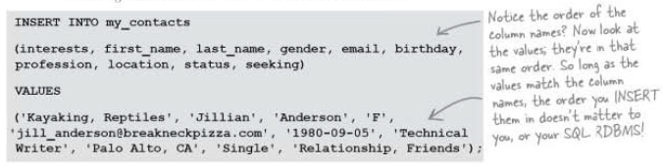

1. **Omitting column names**

You can leave out the list of column names, but the values must be **all** there, and all **in the same order** that **you** **added the columns in.**

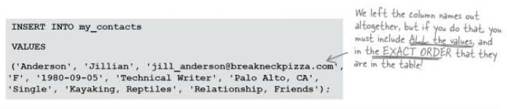

1. **Leaving some columns out**

You can’t insert a few columns and leave some out.

